

**CS331**

**Programming Language Lab**

**ASSIGNMENT - 3 PROLOG**

Naman Anand

200101070



**Que 1**

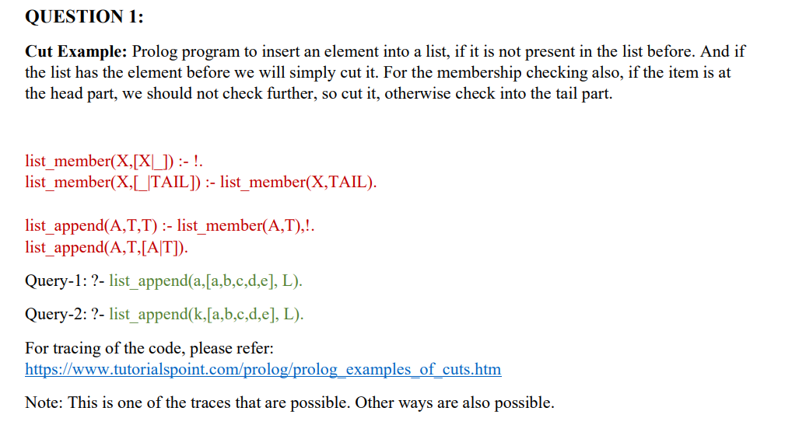

Ans.

**Code :**

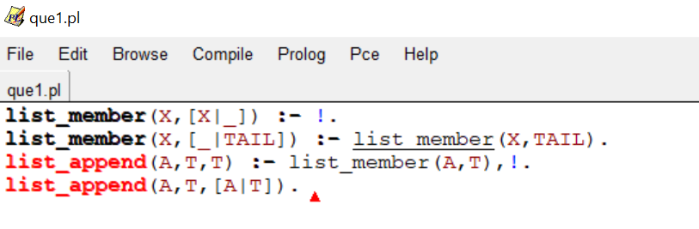

**Query Execution :**

Query1 : **Query-1: ?- list_append(a,[a,b,c,d,e], L).**

|  |
| --- |
| With Trace : |

Query2 : **Query-2: ?- list_append(k,[a,b,c,d,e], L).**

|  |
| --- |
| With Trace : |

**Que 2**

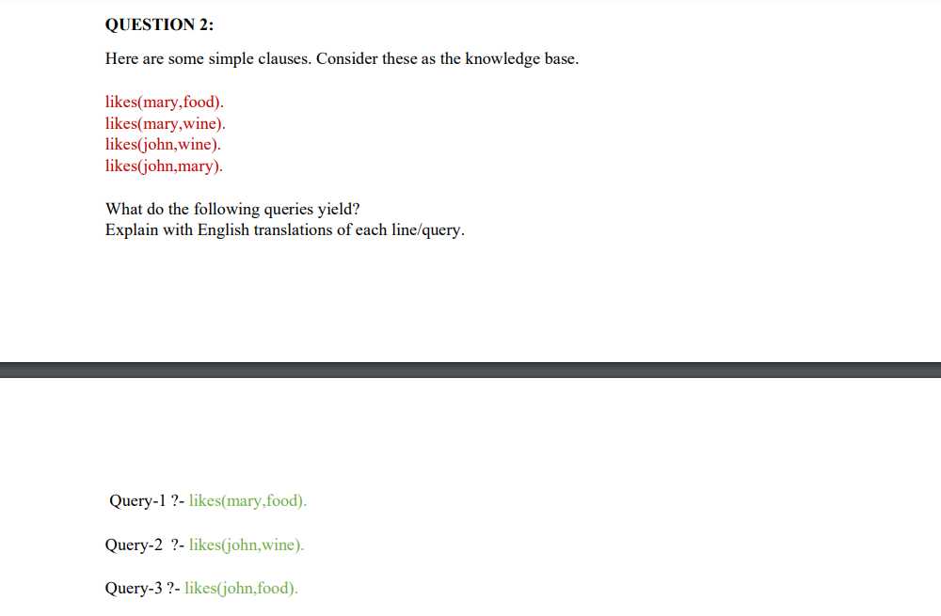

Ans

**Knowledge base :**

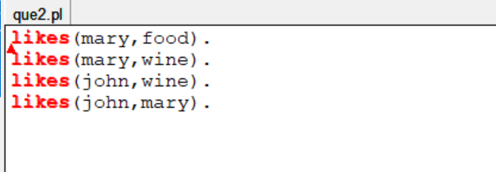

These following lines means :

*mary likes food.*

*mary likes wine.*

*john likes wine.*

*john likes mary.*

**Queries :**

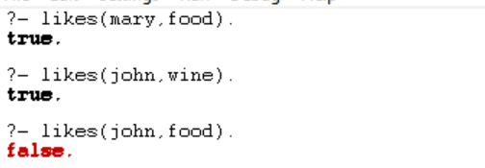

Query 1 :

It is asking if mary likes food. It is a Direct fact hence it is true.

Query 2 :

It is asking if john likes wine. It is a Direct fact hence it is true.

Query 1 :

It is asking if john likes food. But no fact tells us about this hence it is false.

**Que 3**

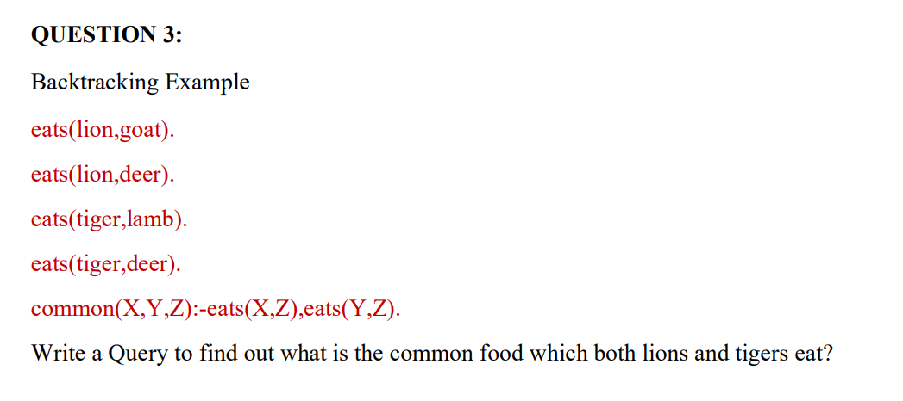

Ans

**Code :**

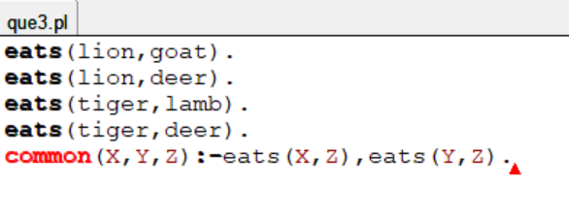

**Query :**

*to find out what is the common food which both lions and tigers eat?*

* **common(tiger,lion,Z).**

**or**

* **common(lion,tiger,Z).**

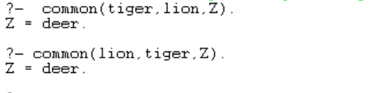

We can also see that it is true as tiger eats deer and lion also eats deer according to our knowledge base.

**Que 4**

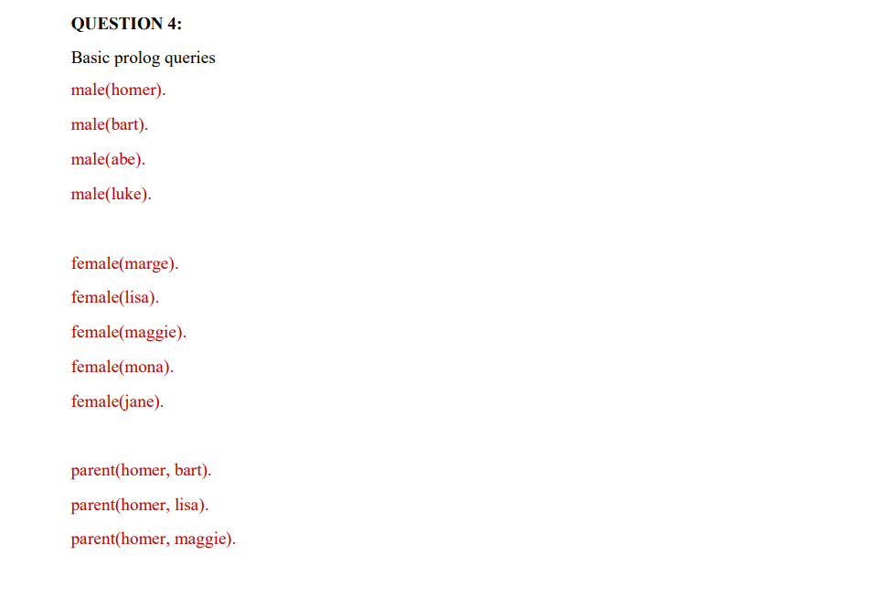 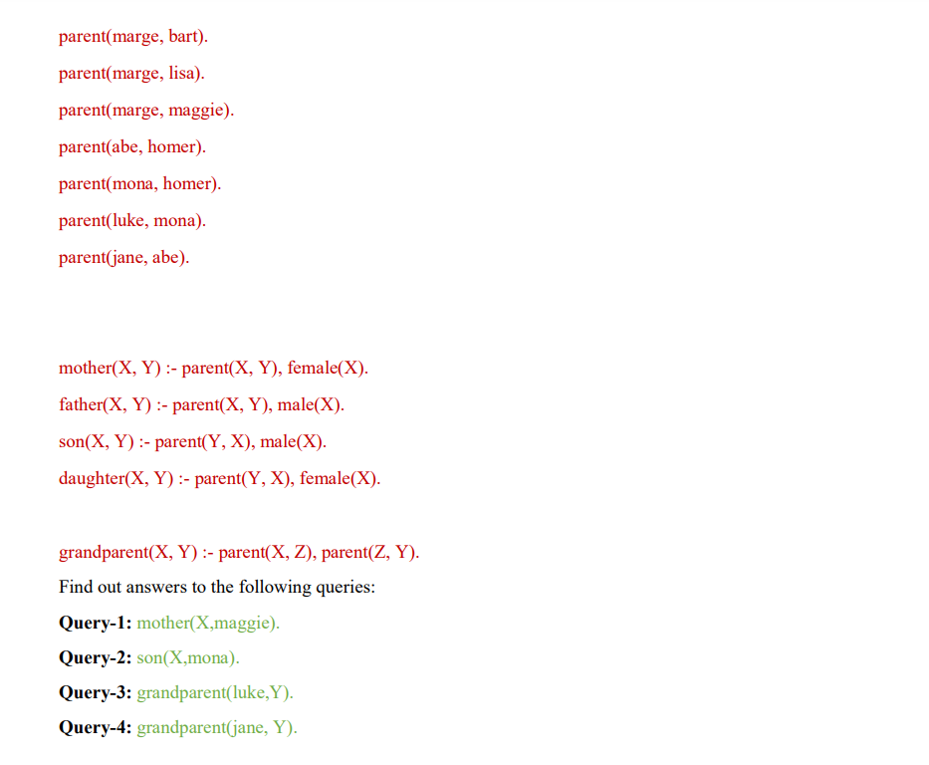

Ans

Knowledge Base :

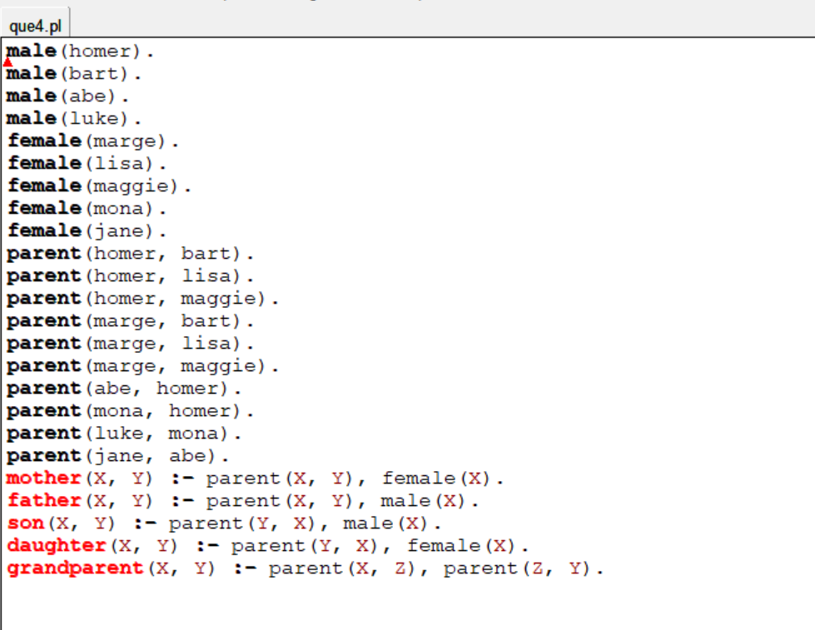

Queries :

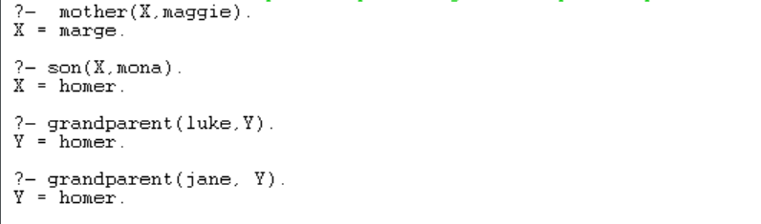

**Query 1 :**

It checks who is mother of maggie.We know if X is mother of maggie then X is parent of maggie and X is female. So after checking for all possible values we got X = marge.

**Query 2 :**

It checks who is son of mona.We know if X is son of mona then mona is parent of X and X is male. So after checking for all possible values we got X =homer.

**Query 3 :**

It checks luke is grandparent of whom. So after checking for all possible values we got Y =homer.

**Query 4 :**

It checks jane is grandparent of whom. So after checking for all possible values we got Y = homer.

*Thank You*